2) Conditions and loops

Agenda
- While loop
- For loop
- Bigger/smaller than
- Import

Guess the secret number
Homework from the previous lesson was to build a game called Guess a secret number. If you did it correctly, it looks something like this:
As you see in the last line, it’s possible also to convert a number into a string (using the str() function).

Make user guess more than once
So far our game let’s you guess only once. We’d like to give our user ability to guess multiple times. To achieve this, we have to use loops.
When you use a loop it means that some part of the code (that’s in the loop) will constantly run, until some condition is met.
You can imagine a loop as a roundabout.
You drive into a roundabout in some foreign city and you’re trying to figure out where you have to go next.
Until you figure that out (condition), you are circling in the roundabout. When you finally figure it out (or your GPS starts working), you go out of the loop.
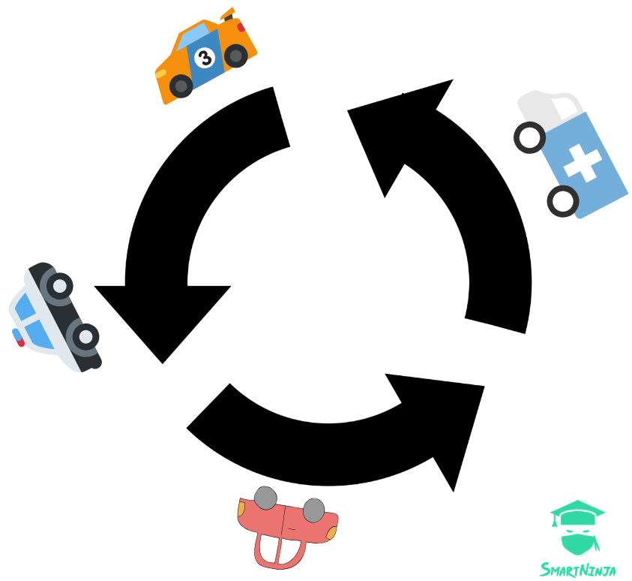
There are two types of loops: while loop and for loop.

While loop
Let’s first use while loop in our program. The basic logic is this: keep asking the user what the secret number is (loop) until user makes the right guess (condition).
It’s a pretty simple implementation: while user’s guess is not equal (!=) to the secret, keep running the code in the loop. When the guess is equal to secret, the code in the loop doesn’t run anymore.
Note that we had to define guess as 0 first, otherwise we wouldn’t be able to write while guess != secret. You cannot use a variable before you declare it.
In this example we keep asking the user what the secret number is, until the user makes the right guess. But what about if we want to limit user’s guess to 5 attempts? The best way would be to use a for loop instead.

For loop
The difference between while and for loop is that with while loop we cannot know how long it will run - this means how many times the code will be repeated. It can run forever (so called infinite loop or endless loop), but this is something we usually don’t want to do.
For loop, on the contrary, has limited “repeats”. In our case, for loop will run only 5 times. Let’s implement this:
We added two things here:
- for x in range(5): this means the code will run 5 times and each time the x variable will hold a different number (you can add print x to your code to see it).
- break: this is a special keyword that helps you stop the loop. In our case we want to stop the loop if the user guesses the right number (even if the loop hasn’t had all the 5 cycles yet).

While + Break
This break thing is interesting, right? We could also use it in the while loop. In this case, we could write our program a bit differently:
We wrote our while loop a bit differently here. We used while True, which basically create that endless loop we mentioned before. This means our while loop will run forever. The only way to stop it is using the break keyword.

Hint: is your guess too big or too small?
Another thing to improve our little game would be to give our users a hint if their guess was too big or too small. Here we use simple bigger than (>) and smaller than (<) symbols:
We just added two new elif statements which check if the guess was bigger or smaller than the secret number and give user a friendly hint.

Random
The last thing to improve in our program is to have our computer to choose a random number as a secret. So far we had the number 22 written, but it will be more fun if our computer chooses a number on random.
To enable this, we'll have to import a library called random. Write this at the top of your program:
What is a library? It's just a file with some code that some other developers wrote and which we can use in our projects. This way we don't have to reinvent the wheel.
Next change the value of the secret variable into this:
This means the computer will randomly select a number between 1 and 30 (including 1 and 30).
And because computer will select a random number each time, we have to change our "success" message into this:
The whole program now looks like this:
Run the program and have fun playing your first Python game! ;)

Q&A
Any question?
If there's enough time after Q&A, students can start working on their exercises and homework.

Exercise 2.1: Unit converter
Students can do this exercise in pairs.
Create a program that converts units. Specifically kilometers into miles.
First create a plan for this program. Together with the instructor define the steps the user will take when using the program.
Plan:
- The program greets user and describes what's the purpose of the program.
- The program asks user to enter number of kilometers.
- User enters the amount of kilometers.
- The program converts these kilometers into miles and prints them.
- The program asks user if s/he'd want to do another conversion.
- If yes, repeat the above process (except the greeting).
- If not, the program says goodbye and stops.
The program should constantly run as long as the user would want to do conversions.

Homework 2.2: FizzBuzz
- User enters a number between 1 and 100
- FizzBuzz program starts to count to that number (it prints them in the Terminal). In case the number is divisible with 3, it prints "fizz" instead of the number. If the number is divisible with 5, it prints "buzz". If it's divisible with both 3 and 5, it prints "fizzbuzz".
Example:
A tip for this project:
How to find a division remainder
If a division remainder is 0, that means some number is divisible with another (without remainder).
Example:
15 is divisible with 5, so the remainder is 0. But 15 is not divisible with 4, so the remainder is not 0.

